**Sales Data Analysis End to End Project Using MySQL and Power BI**

**Problem Statement:**

A small company Axon, which is a retailer selling classic cars, is facing issues in managing and analyzing their sales data. The sales team is struggling to make sense of the data and they do not have a centralized system to manage and analyze the data. The management is unable to get accurate and up-to-date sales reports, which is affecting the decision-making process.

To address this issue, the company has decided to implement a Business Intelligence (BI) tool that can help them manage and analyze their sales data effectively. They have shortlisted Microsoft PowerBI and SQL as the BI tools for this project.

The goal of the capstone project is to design and implement a BI solution using PowerBI and SQL that can help the company manage and analyze their sales data effectively. The solution should be able to:

1. Import and integrate the data from MySQL database into PowerBI
2. Clean and transform the data to make it ready for analysis.
3. Build interactive dashboards and reports using PowerBI that can help the sales team and management make sense of the data.
4. Use SQL to perform advanced analytics on the data and extract insights that can help the company improve its sales (if needed).
5. Enable the management to access the dashboards and reports in real-time and make data-driven decisions.

The solution should be user-friendly and easy to use for the sales team and management. The project will be successful if it helps the company effectively manage and analyze their sales data and improve their decision-making process.

To solve the above capstone project, the given steps can be followed:

1. Use the data source provided: Use the MySQL database provided as a data source.
2. Extract and clean the data: The next step is to extract the data from the identified sources and clean it to make it ready for analysis. This may involve tasks such as removing duplicates, handling missing values, and ensuring data consistency.
3. Load the data into a PowerBI: The cleaned data can then be loaded into a centralized database.
4. Design the dashboards and reports: Using PowerBI, data can be visualized in the form of interactive dashboards and reports. These dashboards and reports can be designed to provide useful insights and information to the management.
5. Deploy the solution: The final step is to deploy the BI solution, including the dashboards, reports, and advanced analytics, to the sales team and management. The solution should be user-friendly and easy to use to ensure adoption and success.

**Steps Involved:**

1. Extract the data into PowerBI from MySQL.
2. Data Formatting
3. Data Modelling
4. Design Dashboards and Report

**1.Data Extraction And Formatting:**

The data is present in the MySQL database under the name classicmodels.

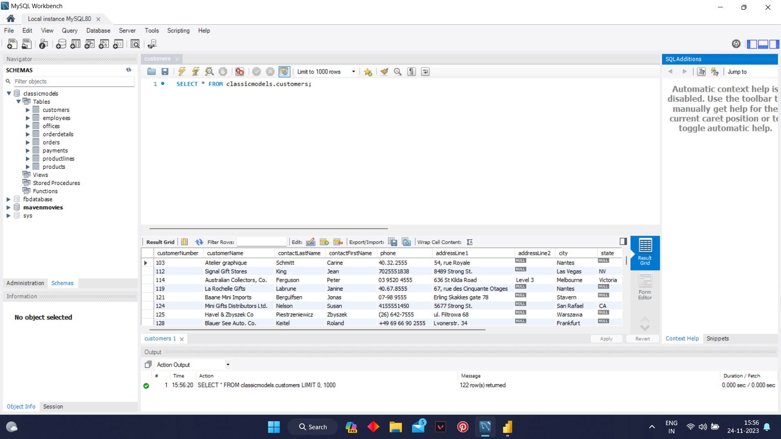

We need to load it into PowerBI. For that first we have to download MySQL connector. After downloading the connector we need to connect the powerBI to MySQL .

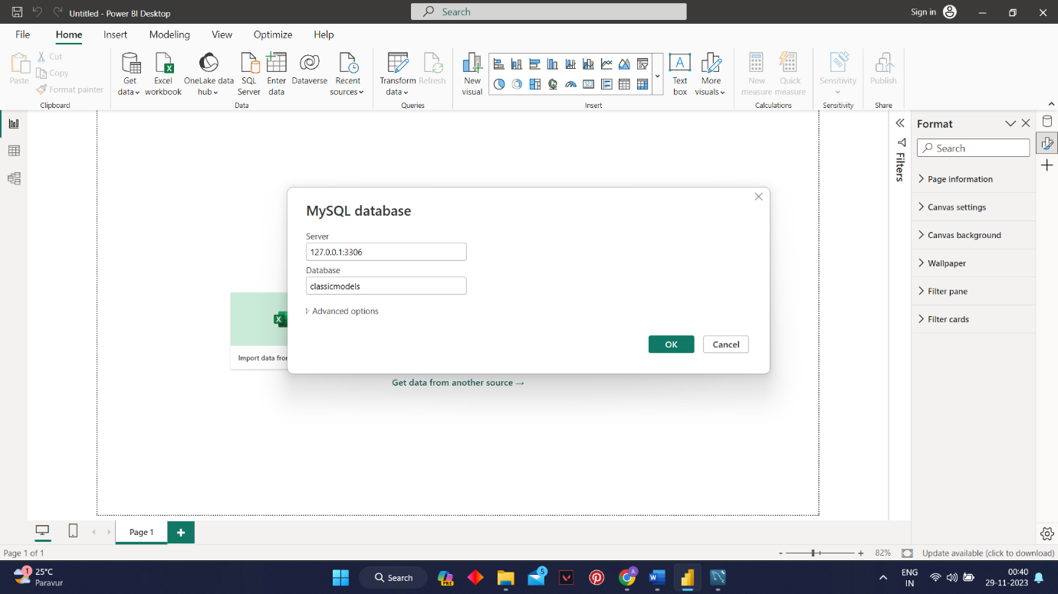

By Entering the server and database details and the username and password we can connect PowerBI to MYSQL. Afrer that we need to load all the tables into PowerBI.

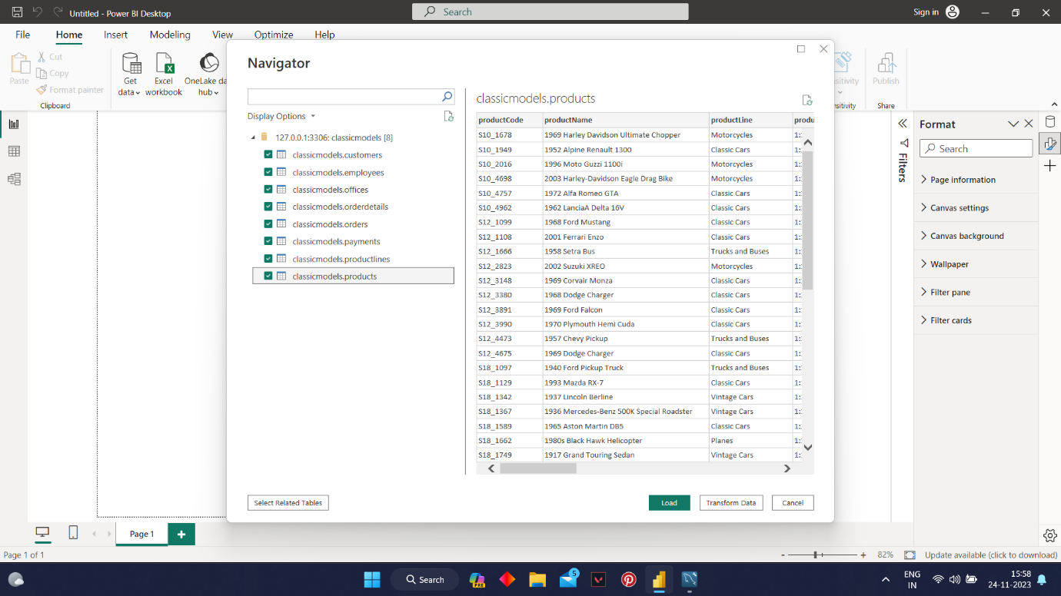

Here we need to transform before loading the tables to check for duplicates, column names, null values and data consistency.

After that load the tables.

**2.Data Modelling:**

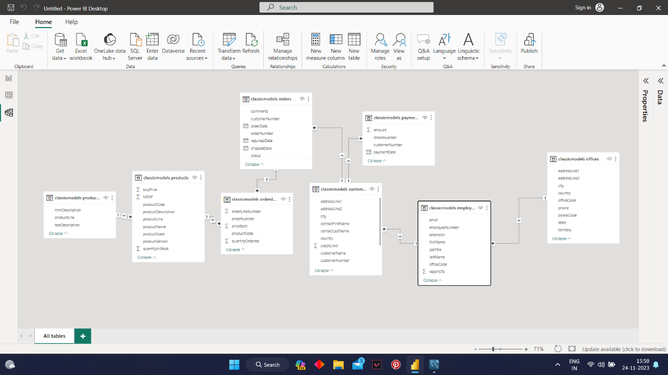

If we look here, we can see that these tables follow Snowflake schema. For Seamless calculation and presentation, we need to convert it into Star schema. I have done that by merging necessary tables in the model and finally converted it into Star Schema.

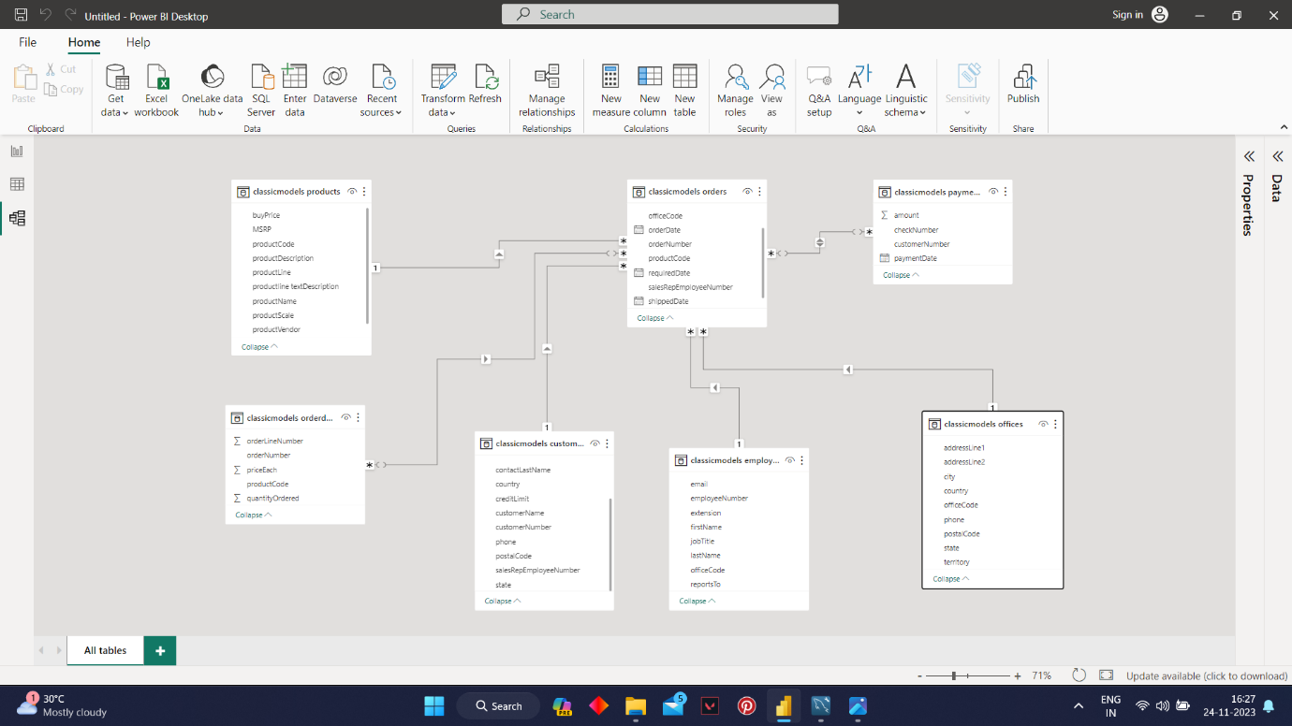

Here we have done the data modelling by necessary merging and relation building.

We can load this data model into database for future analysis.

**3.Designing Dashboards and Reports:**

By understanding the data, I have built various KPI’s and Charts in PowerBI to get various insights about the company by analysing the data effectively. For detailed view you can view the PowerBI file.

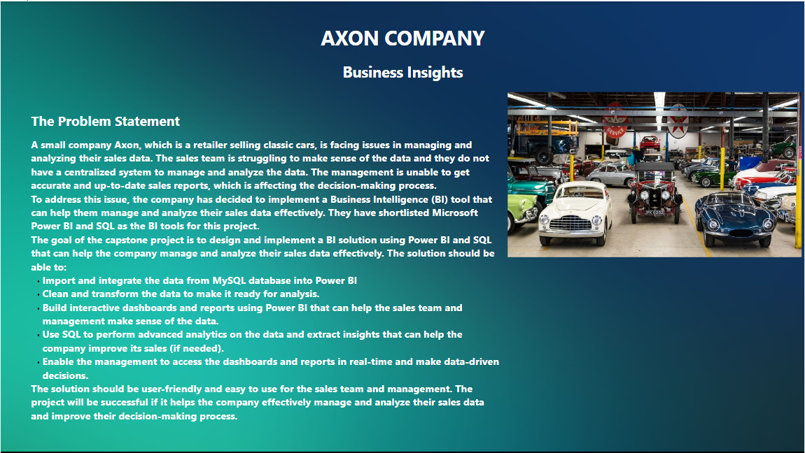

Here I have analysed various charts and built the company’s KPI’s

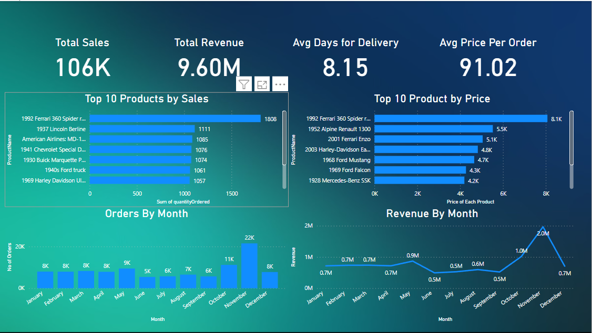

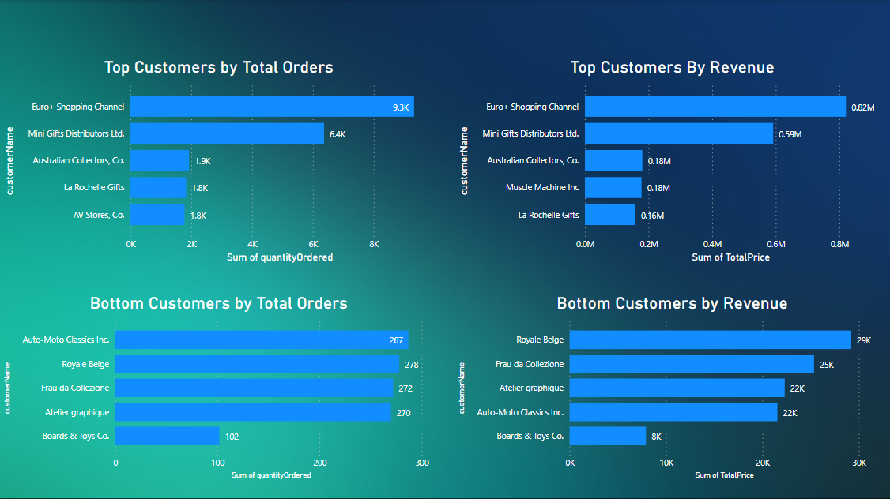

Build charts to find the Top Customers and the Bottom Customers to improve sales

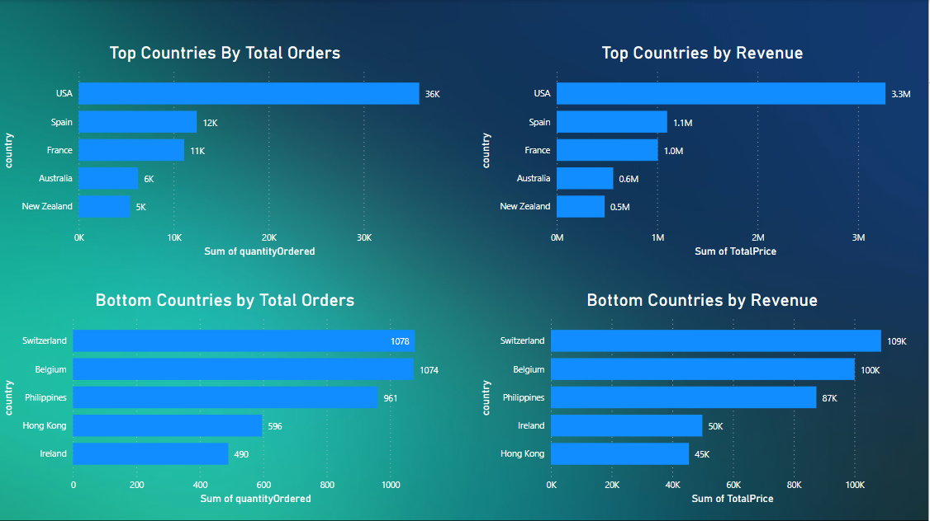

Build Charts to find the Top Countries and the Bottom Countries so that we can focus on the Top Countries to improve sales and revenue

I have also built charts to get insights about top employees who have generated maximum orders and we can relocate them to the countries that has high potential of sales.

I have also built charts for inventory management so that we can reorganise the inventory according to the business performance.

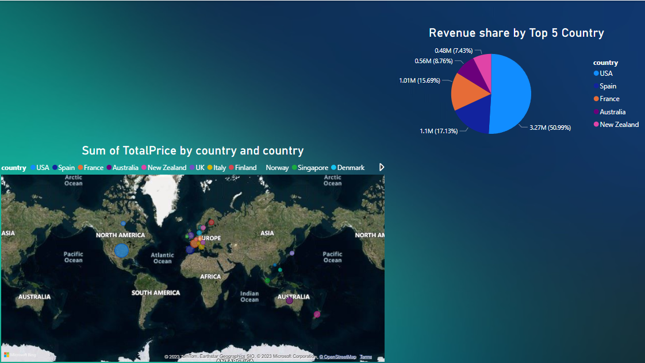

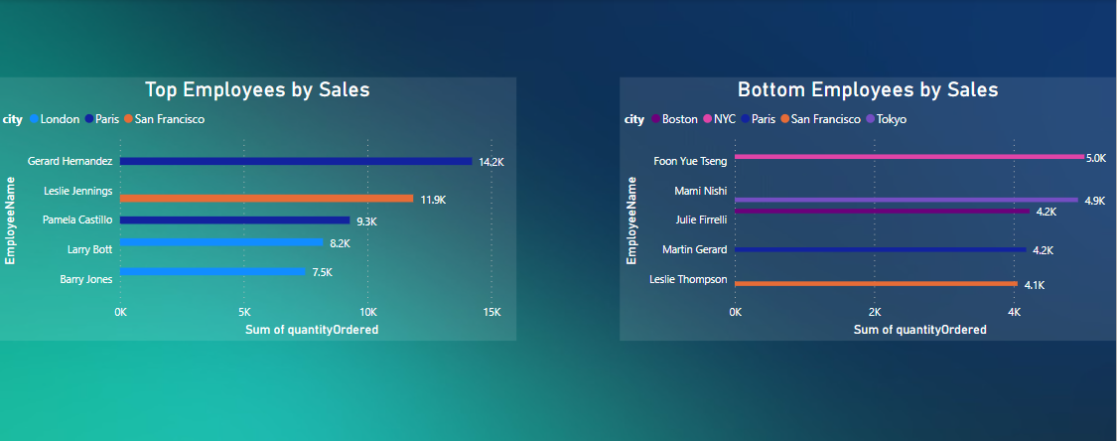

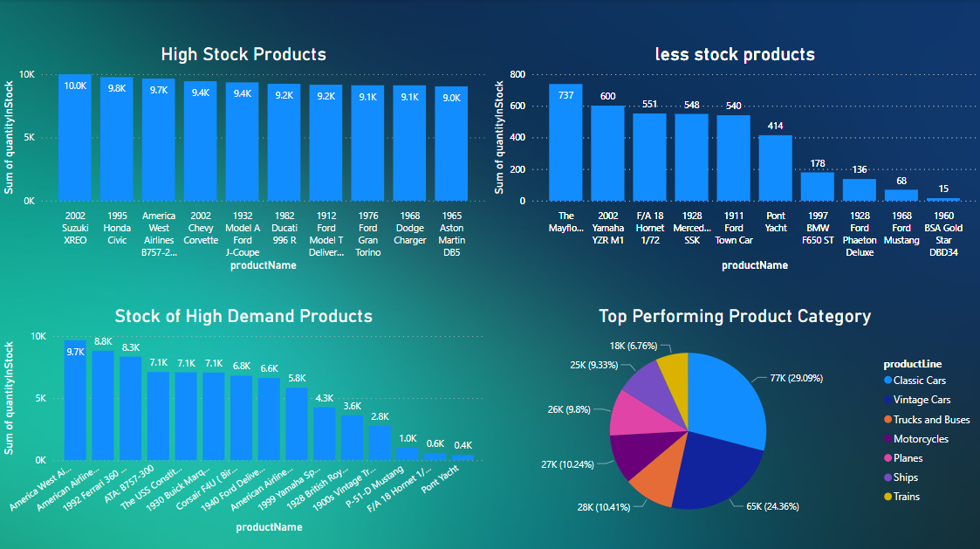

**4.Final Dashboard:**

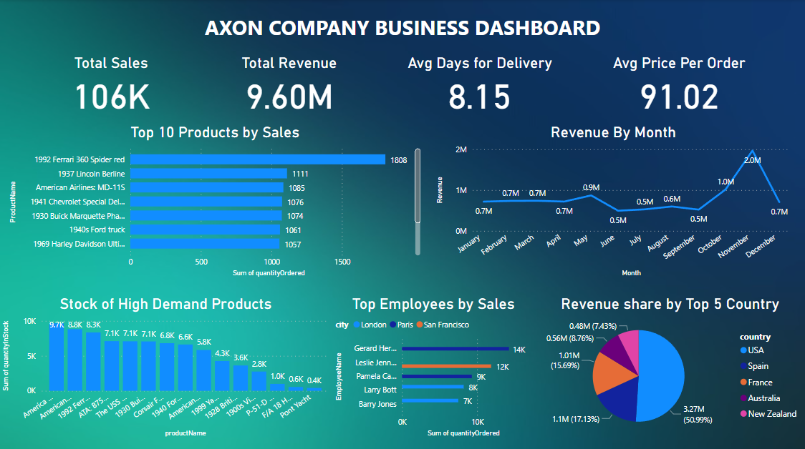

Advanced Analytics on MySQL:

Q1. Total Revenue ad sales generated over the years



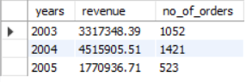

Q2. Total Sales and Growth by Subcategory

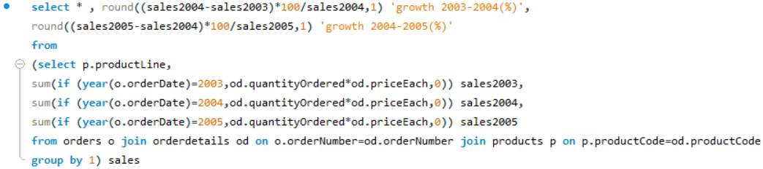

As you can see from the output the total sales in 2005 was very low compared to the total sales in 2004 .

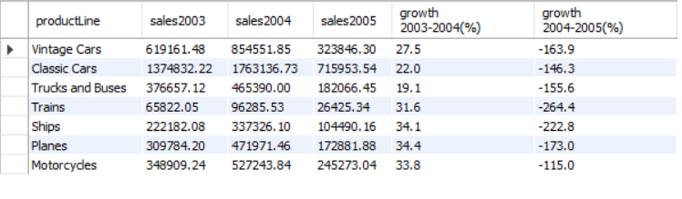

Q3. Total Customer Transactions over Years

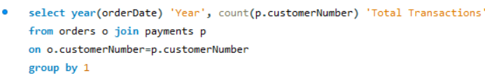

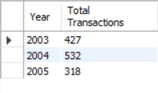

Q4. New Customers over the years

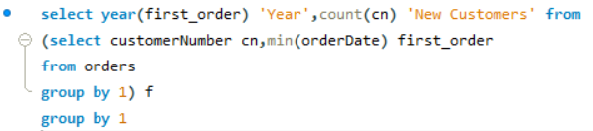

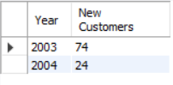

Here we can see that no new customers in 2005. So we have to take necessary actions to promote to get new customers

Other Analysis are done on the PowerBI. You can view the file or you can see above.